### **Community Service Project Report**

### **on**

### **YOGA AWARENESS AND PRACTICES**

### 

## DEPARTMENT OFCOMPUTER SCIENCE

## PRIYADARSINI INSTITUTE OF TECHNOLOGY AND MANAGEMENT

(Approved by AICTE, New Delhi, Affiliated to JNTUK)

5Th Mile, Pulladigunta, kornepadu Village, Vatticherukuru Mandal, Guntur Dist, Andhra Pradesh.

## PRIYADARSINI INSTITUTE OF TECHNOLOGY AND MANAGEMENT



**CERTIFICATE**

This is to certify that the thesis entitled **“**YOGA AWARENESS AND PRACTICES**”** is a Bonafiede project work carried out by “**P.Prasanth kumar,P.Gopi Hanuma,K.Rahul kalyan,J.Koti Reddy, V.Rajya Lakshmi,Mani Chandhar Reddy Manda”**, bearing Reg No **20GK1A0524,20GK1A0528, 20GK1A0513, 20GK1A0511, 21GK5A0507, 21GK5A0504,** worked under my supervision, and submitted in partial fulfillment of the requirements for the award of the degree of **BACHELOR OF TECHNOLOGY** in Computer Science and Engineering during the academic year 2022 - 2023.

**Professor Supervisor: Head of Dept (CSE)**

**Mr.J.Rakesh Mrs. Madhuri Devi**

**Assistant Professor Associative Professor**

**Submitted for Examination held on…………………………………………………...**

**Internal Examiner External Examiner**

**Index**

|  |  |  |
| --- | --- | --- |
| S.No | Topic | Page No |
| 1 | Introduction |  |
| 2 | About the Village / Habitation |  |
| 3 | Socio-Economic Survey of the Village/ Habitation |  |
| 4 | Data collection using prescribed formats |  |
| 5 | Problems identified and Analyses of the problems |  |
| 6 | Short-term and long term action plan for possible solutions |  |
| 7 | Community Awareness Programmes Outcomes |  |
| 8 | Recommendations and conclusions |  |

**Introduction**

Abstract

In the present scenario, the world is facing crisis in terms of endurance and survival. Everyone in order to fulfill their needs are struggling a lot due to which their mental state has affected a lot. However, struggle is also necessary to fulfil the basic needs of our life. Since these things cannot be controlled but an alternative way can be found regarding the same. Yoga has gained importance from past few years as it provides improved mental state boost immunity. In order to analyze the importance of yoga in one’s life a survey is conducted and presented in the present paper. The survey comprises of 250 participants arranged in four different groups ranging from 19-25 years (Group 1), 26-35 years (Group 2), 36-55 years (Group 3) and 56-75 years (Group 4). A questionnaire was provided to them and their responses was collected. The response were then analyzed and results were concluded. It was observed that, the all the groups preferred yoga and practice it in their life. All the participants found yoga advantageous in their life as it helps them to attain inner peace, productive mind, strong immunity and balanced work life as well. Thus it can be concluded that, practicing yoga makes life healthy and cherishable.

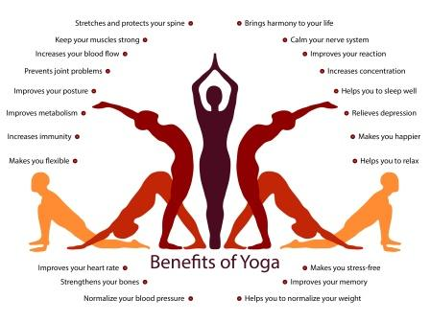

About the Village / Habitation.

Pulladigunta is a Village in Vatticherukuru Mandal in Guntur District of Andhra Pradesh State, India. It belongs to Andhra region . It is located 7 KM towards South from District head quarters Guntur. 6 KM from Vatticherukuru. 281 KM from State capital Hyderabad  
  
Pulladigunta Pin code is 522017 and postal head office is Etukuru .  
  
Kornepadu ( 2 KM ) , Kurnoothala ( 3 KM ) , Etukuru ( 3 KM ) , Ananthavarapadu ( 3 KM ) , Chamallamudi ( 4 KM ) are the nearby Villages to Pulladigunta. Pulladigunta is surrounded by Guntur Mandal towards North , Prathipadu Mandal towards west , Chebrole Mandal towards East , Pedakakani Mandal towards East .  
  
Guntur , Ponnur , Tenali , Mangalagiri are the near by Cities to Pulladigunta.

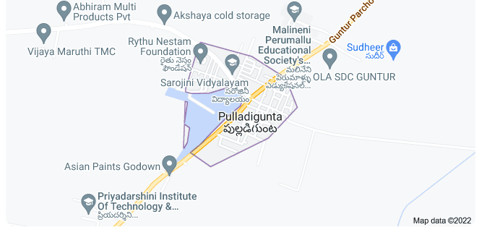

Conducted the survey in pulladigunta about the Yoga awareness and practices. With team of five members

|  |  |
| --- | --- |
| S.No | Team Members |
| 1 | P.Prasanth kumar |
| 2 | .P.Gopi Hanuma |
| 3 | K.Rahul kalian |
| 4 | J.Koti Reddy |
| 5 | V.Rajya Lakshmi |
| 6 | Mani Chandhar Reddy Manda |

**Socio-Economic Survey of the Village/ Habitation**

**Socio-Economic Survey of the Village/ Habitation**

Design:

The survey was conducted by involving participants of different age group. The study involved individuals of different age group. The participants were both male and female. The participants were categorized into different age group and then selected. Four groups were made categorized on the basis of age. The age category was classified as 19-25 years, 26-35 years, 36-55 years, 56-75 years

|  |  |
| --- | --- |
| **Table 1. Classification of Participants**  **on the Basis of Age in Years** | |
| **Participants** | **Age category (in years)** |
| Group 1 | 19-25 |
| Group 2 | 26-35 |
| Group 3 | 36-55 |
| Group 4 | 56-75 |

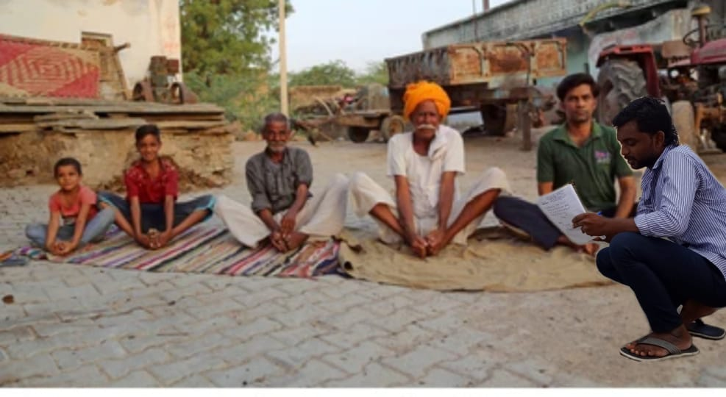 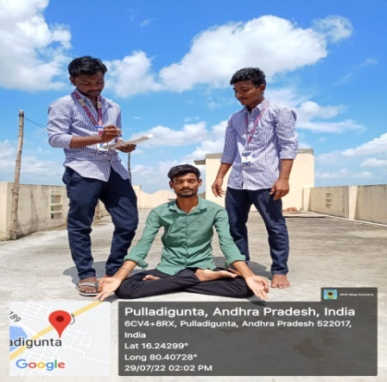

**Questionnaire Involved for Conducting Survey**

|  |  |
| --- | --- |
| **Table 2. Questionnaire Involved for Conducting Survey** | |
| **S.No.** | **QUESTIONS** |
| 1. | How frequently you have practiced yoga in last 6 months? |
| 2. | How much rest does the body needs  between yoga sessions? |
| 3. | What is the source of yoga? Do you  prefer online classes or go to yoga centers? |
| 4. | Apart from Yoga are you involved in any physical activity like walking, heavy  exercises and alike? |
| 5. | What kind of diet you prefer? Veg,  non-veg, vegans? |
| 6. | Do you smoke or consume alcohol?a |
| 7. | Are you involved in any kind of abusive  practices like drugs or faulty medicines? |
| 8. | Why you prefer yoga? |

Data collection using prescribed formats.

Sample format

|  |  |  |  |  |  |  |  |
| --- | --- | --- | --- | --- | --- | --- | --- |
| **S.NO** | **NAME** | **AGE** | **VILLAGE** | **1. How frequently you have**  **practiced yoga in last 6 months?** | **2.How much rest does the body needs**  **between yoga sessions?** | **3.What is the source of yoga? Do you prefer**  **online classes or go to yoga centers?** | **4. Apart from yoga are you involved in any physical activity**  **like walking, heavy exercises and alike?** |
|  |  |  |  |
| 1 |  |  |  |  |  |  |  |
| 2 |  |  |  |  |  |  |  |
| 3 |  |  |  |  |  |  |  |
| 4 |  |  |  |  |  |  |  |
| 5 |  |  |  |  |  |  |  |
| 6 |  |  |  |  |  |  |  |

**Sample format**

|  |  |  |  |  |  |  |  |
| --- | --- | --- | --- | --- | --- | --- | --- |
| **S.NO** | **NAME** | **AGE** | **VILLAGE** | **5.What kind of diet you prefer?**  **Veg, non-veg, vegans?** | **6. Do you smoke or**  **consume alcohol?** | **7.Are you involved in any kind of abusive**  **practices like drugs or faulty medicines?** | **8. Why you prefer yoga?** |
|  |  |  |  |
| 1 |  |  |  |  |  |  |  |
| 2 |  |  |  |  |  |  |  |
| 3 |  |  |  |  |  |  |  |

**Analysis**

**Problems identified and Analyses of the problems**

**Sample:** The survey involved planned questionnaire involving selected questions necessary for the survey. The questions were regarding daily life routine, any bad habits like smoking, drinking and alike and how much time they give to yoga. 250 participants were there for the survey classified as 50 members in each group i.e. each group comprising 50 members each.

**Instrument:** The response from the participants were analyzed thoroughly by conducting a thorough research by a committee of experienced members. While conducting the survey, most important part is the questionnaire with important questions. This is so because selected questions aids in analyzing the perspective of each participants. Four options regarding each question was provided to the participants, comprising, yes, no, never, sometimes. The questionnaire involved herein are as follows: (Table 2).

**Data collection**

|  |  |  |  |  |
| --- | --- | --- | --- | --- |
| **1. How frequently you have practiced yoga in last 6 months?** | | | | |
| **Subjects** | **Response** | | | |
| **Daily** | **Thrice a week** | **Once a week** | **Once a month** |
| GROUP 1 | 20% | 25% | 40% | 50% |
| GROUP 2 | 25% | 20% | 35% | 5% |
| GROUP 3 | 50% | 20% | 15% | 5% |
| GROUP 4 | 90% | 15% | 10% | 3% |

|  |  |  |  |  |
| --- | --- | --- | --- | --- |
| **2. How much rest does the body needs between yoga sessions?** | | | | |
| **Subjects** | **Response** | | | |
| **15 min** | **30 min** | **1 hrs** | **No rest** |
| GROUP 1  GROUP 2 | 25%  25% | 20%  27% | 10%  5% | 0%  2% |
| GROUP 3 | 30% | 20% | 5% | 2% |
| GROUP 4 | 45% | 30% | 5% | 5% |

|  |  |  |  |  |
| --- | --- | --- | --- | --- |
| **3. What is the source of yoga? Do you prefer online classes or go to yoga centers?** | | | | |
| **Subjects** | **Response** | | | |
| **Online**  **classes** | **Yoga**  **centers** | **At your**  **premise** | **Park** |
| GROUP 1 | 50% | 10% | 20% | 5% |
| GROUP 2 | 40% | 20% | 50% | 25% |
| GROUP 3 | 30% | 50% | 35% | 40% |
| GROUP 4 | 5% | 45% | 10% | 80% |

|  |  |  |  |  |
| --- | --- | --- | --- | --- |
| **4. Apart from yoga are you involved in any physical activity like walking, heavy exercises and alike?** | | | | |
| **Subjects** | **Response** | | | |
| **Yes** | **No** | **Never** | **Sometimes** |
| GROUP 1  GROUP 2 | 90%  70% | 5%  10% | 0%  5% | 5%  15% |
| GROUP 3 | 50% | 30% | 20% | 10% |
| GROUP 4 | 40% | 50% | 0% | 10% |

|  |  |  |  |
| --- | --- | --- | --- |
| **5. What kind of diet you prefer? Veg, non-veg, vegans?** | | | |
| **Subjects** | **Response** | | |
| **Vegetarian** | **Non Vegetarian** | **Vegan** |
| GROUP 1 | 60% | 45% | 2% |
| GROUP 2 | 60% | 40% | 5% |
| GROUP 3 | 70% | 20% | 5% |
| GROUP 4 | 95% | 5% | 0% |

|  |  |  |  |  |
| --- | --- | --- | --- | --- |
| **6. Do you smoke or consume alcohol?** | | | | |
| **Subjects** | **Response** | | | |
| **Yes** | **No** | **Never** | **Sometimes** |
| GROUP 1  GROUP 2 | 85%  70% | 10%  30% | 10%  20% | 25%  10% |
| GROUP 3 | 20% | 40% | 5% | 30% |
| GROUP 4 | 5% | 90% | 5% | 5% |

|  |  |  |  |  |
| --- | --- | --- | --- | --- |
| **7.Are you involved in any kind of abusive practices like drugs or faulty medicines?** | | | | |
| **Subjects** | **Response** | | | |
| **Yes** | **No** | **Never** | **Sometimes** |
| GROUP 1  GROUP 2 | 25%  35% | 30%  20% | 10%  15% | 20%  25% |
| GROUP 3 | 15% | 10% | 50% | 25% |
| GROUP 4 | 0% | 95% | 95% | 5% |

|  |  |
| --- | --- |
| **8. Why you prefer yoga?** | |
| **SUBJECTS** | **RESPONSE** |
| GROUP 1 | Yoga is advantageous as it aids in getting  rid from tension, develops a positive energy, and also maintains a balance between professional and personal life. Moreover, it keeps  physically fit and active throughout a day. |
| GROUP 2 | Yoga is beneficial as it provides mental  fitness, boost immunity, and gives inner peace. |
| GROUP 3 | It prevents aging, joint pains and also relieves from  stress caused due to management of personal and professional life. |
| GROUP 4 | It boost immunity, provides inner peace, and are active to perform their own work. |

**Short-term and long term action plan for possible solutions**

**Short-term and long term action plan for possible solutions**

**1.How frequently you have practiced yoga in last 6 months?:** Yoga has become the most crucial activity in one’s life when consideration to medical and physical fitness is given. It has gained immense importance in the entire world. It makes the mind calm, relieves stress, makes the body physically fit and keeps the person active throughout the day. Practicing yoga is very important in order to enhance the mental state. On asking the review of participants on how frequently they practice yoga their responses were somewhat same and lie within same order. Participants belonging to group 1 preferred yoga only once a month. 50% of them preferred yoga once a month. Participants belonging to group 2 preferred yoga once a week (25%), group 3 preferred yoga daily (50%) and participants belonging to group 4 preferred yoga daily (90%).

**2. How much rest does the body needs between yoga sessions?:** Having a break from day to day routine is very important without any question. Breaks relaxes the mind and refresh the brain and makes it more productive. While doing continuous exercises muscles stretch a lot, due to which oxygen levels decrease in the muscles and glucose metabolism decreases due to which the person feels so weak and lame. In worst condition sometimes the person even faint. From the survey it was observed that, all the participants preferred rest in yoga sessions. Participants belonging to group 1 preferred a rest for 15 min (25%) while participants belonging to group 2 preferred rest for 30 min. and 3 and 4 preferred rest for 15 min. respectively

**3. What is the source of yoga? Do you prefer online classes or go to yoga centers?:** Yoga can be accessed at any place, either online or offline as per the need of the user. If one really wants to practice yoga there is no bar in accessing it. But the thing is that one should be keen learner towards it. When the participants were asked about how they access yoga, all the groups gave a mixed answer depending on their need, time, and money and alike. Participants belonging to group 1 preferred online classes, while those in group 2 preferred practicing yoga at their premise. Participants belonging to group 3 preferred yoga at yoga centers and those in group 4 prefer doing so at park. Different perceptions of different people depends upon their lifestyle, and most importantly time management. People belonging to group 1 and 2 are busy with their career and management of day to day activities due to which they prefer to practice yoga either at their premise or via online classes. However person belonging to group 3 and 4 have some extra time and also they like to enjoy company of each other thus they preferred practicing yoga at centers or at parks.

**4. Apart from yoga are you involved in any physical activity like walking, heavy exercises and alike?:** Practicing yoga is good, but still involvement in extra activities is also good to live a healthy life. Involvement in different activities entirely depends on the choice of the person. From the survey it was observed that, participants belonging to group 1 also preferred other physical activities in addition to yoga which was 90% people, while participants belonging to group 2 also preferred physical activities (70%) followed by group 3 (50%) and group 4 (40%).

**5. What kind of diet you prefer? Veg, non-veg, vegans?:** For attaining a proper health a balanced diet, more preferably yogic diet is very important. It gives immense power and keeps the body active. Yogic diet certainly provides a positive attitude to one’s mind which is sufficientenough to maintain a proper health. Form the survey it was observed that, all the participants were vegetarians ranging from group 1 to group 4 (60%-95%) who practice yoga on a regular basis. However, 45% of participants from group 1 also preferred non-vegetarian food. This may be attributable to the fact that, youngsters (19-25 years) possess good digestion capacity in comparison to other age groups thus they can manage the yogic diet accordingly

.

**6. Do you smoke or consume alcohol?:** Smoking and alcohol affects the health adversely. The nicotine and carbon monoxide within smoke affects block the arteries by making the blood thick thus affects the oxygen level within the body and blood flow stops(IRCT20160731029134N2 et. al. (2019)). This consequently affects the exercise practice, stretching of muscles, and thus renders the person inactive. From the survey it was observed that, 85% of participants in group 1 more likely preferred smoking followed by group 2 (70%), group 3 (20%) and very few participants in group 4 preferred smoking and alcohol consumption. From the data above it can be inferred that, consumption of alcohol and smoke affects the health badly due to which participants feel lazy and avoid yoga practice.

**7. Are you involved in any kind of abusive practices like drugs or illegitimate medicines?:** Abusive drugs comprising weeds from cannabis family directly affects the mind and body of the person. Delta-9-tetrahydrocannabinol in the weed alters the mind adversely that renders the mind unconscious for many hours by adversely affecting the sensory motors of the brain(S. Harper et. al. (2012)). Thus it is unethical and illegal to consume abusive drugs. However, still most of the people consume it by arranging them in illegal way. Effect of such abusive drugs adversely affects the life of the person. From the survey it was observed that, participants practicing yoga are not involved in such activities. However, few of them are involved in doing so.

**8. Why you prefer yoga?:** Answer to these questions varied among different groups according to their perception. One thing common among them was that all preferred yoga because of mental peace and stong immunity they get.

.

**Conclusion**

**Conclusion:**

Importance of yoga is multi-dimensional and also its scope has evolved in present era. Thus it can be concluded that yoga is a boon in this modern technological world. Even yoga survey has received international recognition

as well. The aim to conduct the survey was to know the importance of yoga in one’s life. Form the survey conducted comprising different groups it was observed that each and every group practice yoga in their routine. However, their time management and priority differs but still it is a part of their life. The survey also showed that participants were in addition to practicing yoga also have healthy diet, take proper rest, prefer both online and offline sources of yoga according to their needs, refrains from consuming smoke or alcohol and abusive drugs.

This clearly indicates that they are serious about their life and are honest towards practicing yoga. Moreover, they have seen immense improvement in themselves after practicing yoga for 6 months. Each group have different perception towards yoga when they were asked about importance of yoga in their life. But the conclusion from their perceptions was same that they practice yoga in order to have inner peace, enhanced mental state and strong immunity.